Wazuh XDR Endpoint Lab
Part 1 – Agent Deployment and Baseline
Endpoint: Windows 11 (Windows11-Defender in a ProxMox VM)
I installed and registered the Wazuh agent by using a PowerShell script run with administrator privileges. Wazuh automatically reported the Powershell scripts used to install Wazuh as well as the other drivers and protocols involved with installing the Wazuh endpoint.
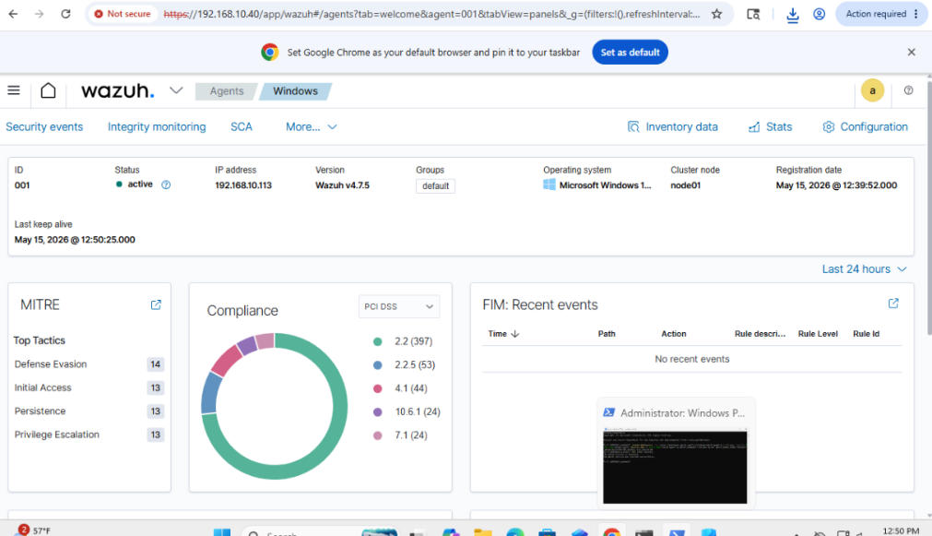
Figure 1 Active Wazuh Agent

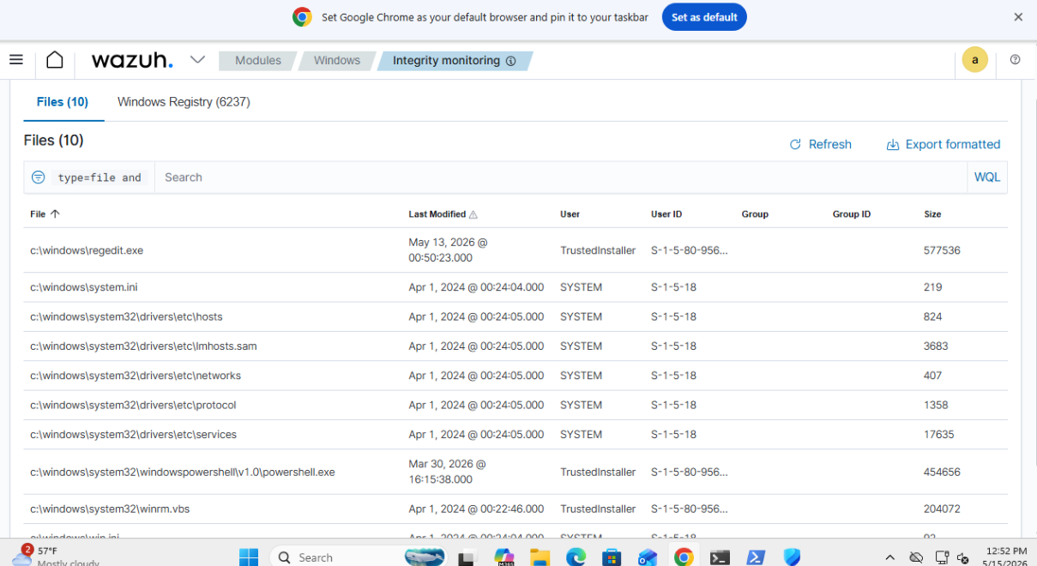
Baseline Observations: After deployment, Wazuh automatically began collecting Windows event logs and system activity from the endpoint. Initial alerts included startup events, service activity, and normal Windows system logs.
Figure 2 Powershell and other Activity generated from Installing Wazuh
Part 2 – Endpoint Events and Alert Analysis
Generated Endpoint Activity
Windows logon success:
Risk Level: Low to Medium
The login activity in this lab was legitimate administrative behavior. However, in a real environment, unusual successful logins or logins at unexpected times could indicate compromised credentials or unauthorized access.
File added to the system:
File Integrity Monitoring was enabled for the C:\Windows\Temp directory. A test file was created inside the monitored directory to generate a Wazuh alert. This alert is important because attackers commonly create or drop files in temp directories during malware execution or staging activity.
Risk Level: Medium
In this lab, the file was benign. However, unexpected file creation in sensitive directories could indicate suspicious or malicious behavior in a different environment.

Part 3 - Configuration Change / Tuning
File Integrity Monitoring Configuration
File Integrity Monitoring (FIM) was enabled for the C:\Windows\Temp directory by modifying the Wazuh agent ossec.conf configuration file.
The following directory was added to the <syscheck> section:
<directories> check_all=”yes”>C”\Windows\Temp</directories>
The Wazuh agent was restarted after the configuration change.

Validation:
After enabling FIM, files were created and deleted in the temp directory. Wazuh successfully generated file integrity alerts showing file creation and deletion activity.
Before the configuration change, this activity was not clearly visible in the dashboard. After enabling monitoring, additional file-related telemetry and alerts were observed.
This type of alert would be useful in a security system because attackers frequently use temporary directories to store scripts, malware, or staging files.
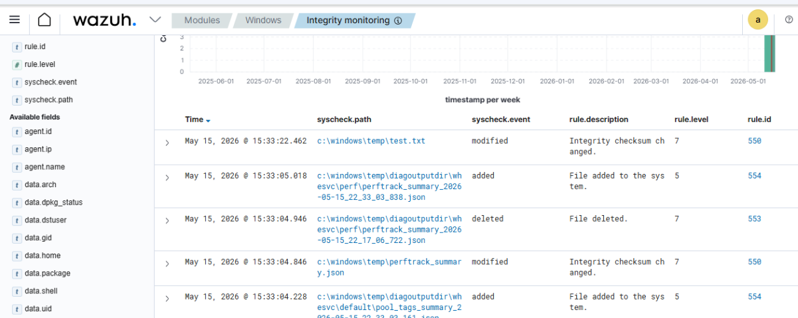
Figure 3 Temp Folder added to Integrity Monitoring and successfully recorded changes

Part 4 – Reflection and Hardening Recommendations
Reflection
Wazuh provided centralized visibility into endpoint activity and made it possible to monitor authentication events, PowerShell execution, and file activity from a sinlge dashboard. The platform was effective for identifying suspicious or administrative behavior and organizing alerts by rule severity and event type. The dashboard also helped correlate endpoint activity with security-related events.
One limitation observed during the lab was that some alerts lacked detailed context, and certain actions required additional filtering or investigation to fully interpret. Large numbers of events can also create alert noise if tuning is not properly configured.
Hardening Recommendations
- Keep Windows Defender or another antivirus solution enabled alongside Wazuh for layered endpoint protection.
- Enable File Integrity Monitoring on important directories such as temporary folders, user download locations, and system configuration paths.
- Monitor and restrict PowerShell usage because it is frequently abused by attackers for malicious activity.
- Monitor failed authentication attempts and unusual account activity to help detect brute-force attacks or unauthorized access.
- Combine Wazuh with additional EDR/XDR solutions to improve detection, prevention, and incident response capabilities.
The data collected by Wazuh can support a broader SOC workflow by helping analysts perform alert triage, investigate suspicious activity, escalate incidents, and conduct threat hunting. Centralized endpoint telemetry improves visibility and supports faster detection and response during security investigations.
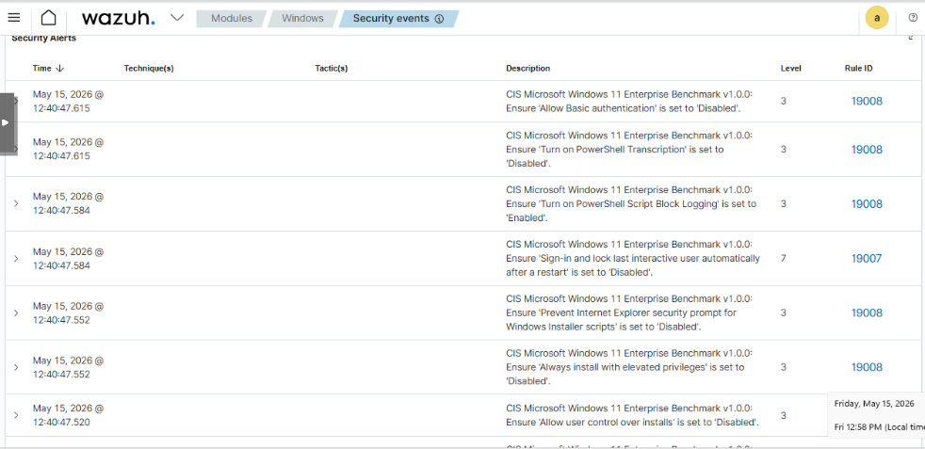
Figure 3 Security changes generated from Malware
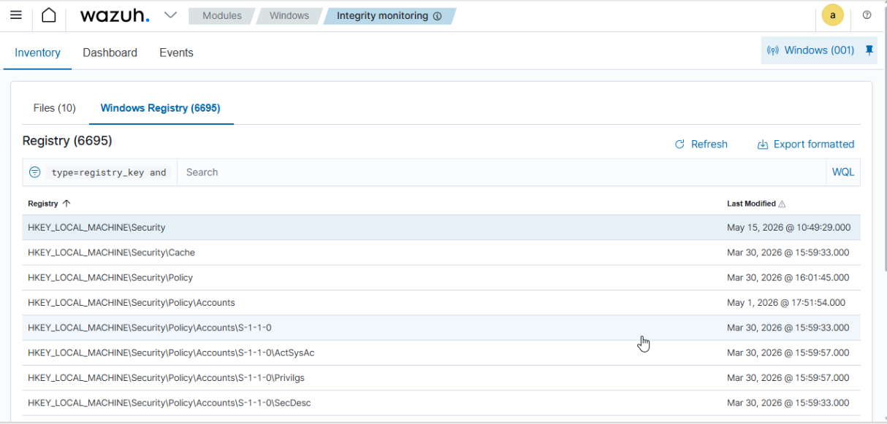
Figure 4 Registry changes generated from Malware

